Talk2Invoice: AI Powered Voice Assistant for Food Ordering and Invoicing
E. Aswani Kumar¹, Bandi Poorna Sri Sailaja², Yamana Balaji Akshay Kumar³, Pulagam Santhoshini⁴, Borra Vikash⁵, Chittidi Kavya Likitha⁶, Yeruwaka Ram Durga Prasad⁷
¹ Professor, Department of Artificial Intelligence and Machine Learning,
Sri Vasavi Engineering College (Autonomous), Pedatadepalli, Tadepalligudem, A.P, India
²–⁷ Department of Artificial Intelligence and Machine Learning,
Sri Vasavi Engineering College (Autonomous), Pedatadepalli, Tadepalligudem, A.P, India
aswaniatsasi@gmail.com
{ sailubandi33, balajiakshay2136, santhoshinireddy028, borra.vikash, kavyalikitha6, yramdurgaprasad}@gmail.com
Abstract
Artificial intelligence is being adopted more in fast-food service environments to make ordering quicker and easier, especially in busy places like metro stations, airports, and self-service kiosks. However, many current solutions don’t meet expectations due to limited voice recognition, lack of real-time inventory updates, and inadequate backend systems. Talk2Invoice is a voice assistant powered by AI that aims to solve these issues by allowing contactless food ordering through natural speech and automating backend tasks. Multilingual voice input is turned into text using OpenAI’s Whisper model, and customer intent along with food item details is identified using a fine-tuned DistilBERT model. QR code-based menu access makes interactions simpler, while a blockchain-enabled backend supports real-time stock management, queue optimization, and secure digital transactions. Once the order is confirmed successfully, digital invoices are automatically generated and sent to users, and analytical reports provide insights into sales trends and service performance. Experimental results show improved order accuracy in noisy settings, and better transparency in transaction handling. By combining speech processing, natural language understanding, and secure backend technologies, Talk2Invoice presents a practical, scalable, and user-friendly method for AI-driven food ordering in modern service environments.
Keywords: Voice Assistant, Speech-to-Text, Whisper (Faster Whisper), DistilBERT, Natural Language Processing, Real-Time Inventory Management, Digital Invoicing; Blockchain.

1. Introduction
Artificial intelligence is reshaping service industries by enabling smart automation and natural human-computer interaction. In fast-food and quick-service restaurant settings, especially in busy places like airports, metro stations, food courts, and self-service kiosks, efficient order placement and transaction handling are crucial for maintaining service quality. Traditional food ordering methods, such as manual counters and touchscreen kiosks, often lead to long lines, order mistakes, and limited scalability during peak hours. These problems have increased the demand for AI-driven solutions that can improve operations and enhance the customer experience.
Voice-based interfaces provide a convenient and contactless option for food ordering. However, current voice assistants often struggle in real-world fast-food environments due to background noise, multilingual interactions, and limited connections to backend systems. These issues frequently cause incorrect intent interpretation, delayed responses, and inconsistent order fulfillment. To tackle these challenges, this study presents Talk2Invoice, an AI-powered voice assistant designed to automate food ordering and invoicing through natural speech interaction, focusing on reliability, scalability, and transparency.
1.1 The Need for Voice-Based Food Ordering Automation
Fast-food environments need quick and precise order processing to handle high customer volumes effectively. Manual and touchscreen systems often cause delays and errors, especially during busy times. Additionally, the growing demand for contactless interactions has made it necessary to have ordering methods that minimize physical contact and are easy to use. Voice-based food ordering offers a natural solution, but its effectiveness relies on strong speech recognition and seamless backend integration. There is a clear need for intelligent voice-driven platforms that combine ordering, inventory checks, and billing into a single automated workflow.
1.2 Challenges in Existing Voice-Based Ordering Systems
Current food ordering systems, including voice-enabled solutions, face several practical challenges:
1. Limited Multilingual Support: Insufficient handling of various languages limits accessibility.
2. Poor Backend Integration: A lack of real-time connections with inventory and billing systems causes order inconsistencies.
3. Latency and Reliability Issues: Delayed responses and intent errors decrease user confidence.
These challenges hinder widespread adoption and show the need for a stronger AI-based approach.
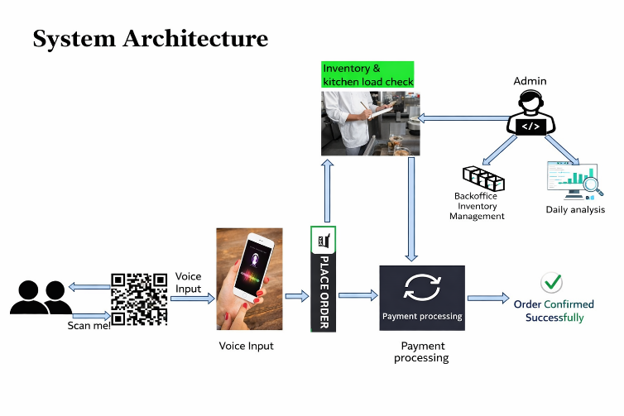 Fig-1: System Architecture of the Talk2Invoive Platform
1.3 Role of Whisper and DistilBERT in Voice Understanding
Talk2Invoice addresses challenges in speech and language understanding by using advanced deep learning models. OpenAI’s Whisper model assists with multilingual speech-to-text conversion and works well even in noisy settings. A fine-tuned DistilBERT model helps with accurate intent recognition and food item extraction from user commands. Together, these models enable reliable voice understanding, while backend automation supports real-time inventory checking, kitchen load balancing, and digital invoice creation.
1.4 Objectives of the Study
The objectives of this study are:
1. To develop a strong voice-based food ordering solution for noisy and multilingual environments
2. To integrate real-time inventory checks and automated digital invoicing
3. To ensure secure and transparent transactions using blockchain technology
4. To assess improvements in order accuracy and response time
1.5 Significance of the Study
This research offers a practical AI-driven solution to key challenges in fast-food operations. By automating ordering and invoicing through voice interaction, Talk2Invoice decreases waiting times, reduces human errors, and improves service consistency. The combination of speech processing, natural language understanding, and secure backend technologies enhances transparency and operational reliability. For service providers, the platform reduces staff workload and enables data-driven decision-making, while customers enjoy a convenient, contactless, and multilingual ordering experience. Overall, this study showcases the potential of AI-powered voice assistants to support scalable and user-friendly food ordering systems in modern service settings.
2. LITERATURE SURVEY
According to the recent studies, there is an increasing trend of applying artificial intelligence to voice-based ordering and the automation of the food service. Srinivasan et al. [1] show that the accuracy of intent recognition in fast-food voice assistants can be dramatically increased by the use of transformer-based NLP models, in particular, DistilBERT. Their study validated the idea that deep learning techniques can be useful in understanding customer orders and provided the basis of the continued evolution of AI-based food ordering systems.
Kim et al. [2] suggested a voice assistance framework that centers on deep learning and emphasizes on speech preprocessing, contextual interpretation and noise suppression. In their research, they indicated that consistent speech-to-text systems are essential to make them work in a real restaurant environment. On the same note, Zhang et al. [3] proposed the implementation of an intelligent food ordering system that includes speech recognition with semantic analysis, which additionally demonstrates the potential and the advantages of AI-based ordering systems.
The potential of voice interfaces to automate restaurants was demonstrated by Shirode et al. [4], who developed a speech-based virtual restaurant clerk based on the Web Speech API and NLP, and the authors of the study. Later, Kumar et al. [5] retrospected the development and use of voice assistants, and usability, system integration, and reliability were cited as such a problem in the real world. Ashfaq et al. [6] also examined the style of chatbot interaction in online food delivery and emphasized that the conversational design and the quality of interactions are the major factors of user engagement and satisfaction.
Patil et al. [7] introduced a voice-assisted online food ordering web-application, which demonstrated excellent practicability and convenience but not secure automated support on the backend and lacked mass evaluation. Rathod et al. [8] also experimented with speech or voice-based restaurant assistants, and found that voice-based ordering and billing worked successfully. This, however, came with constraints on scalability, adaptability and robustness in noisy real world situations due to their dependence on browser-based technologies and predefined dialogue structures.
Much more recently, Huang et al. [9] have suggested a hybrid on-device food ordering system which uses lightweight language models and rule-based elements but focuses on the concern of resource-bound environments and efficiency/scalability. Based on these works, the proposed Talk2Invoice system seeks to address the weaknesses of robustness, end-to-end automation, transformer-based intent understanding, secure blockchain-based invoicing, and analytics-based management support.
3. Methodology
This section presents the process of designing and implementing the solution to the voice-based system of ordering and invoicing food, Talk2Invoice. The method consists of three key elements, which include voice interaction and intent processing, order processing and validation, and backend and administrative management. This systematic methodology shows the functioning of the system since interaction with the customers up to the control side and is a sure way of reliability and efficiency in restaurants. 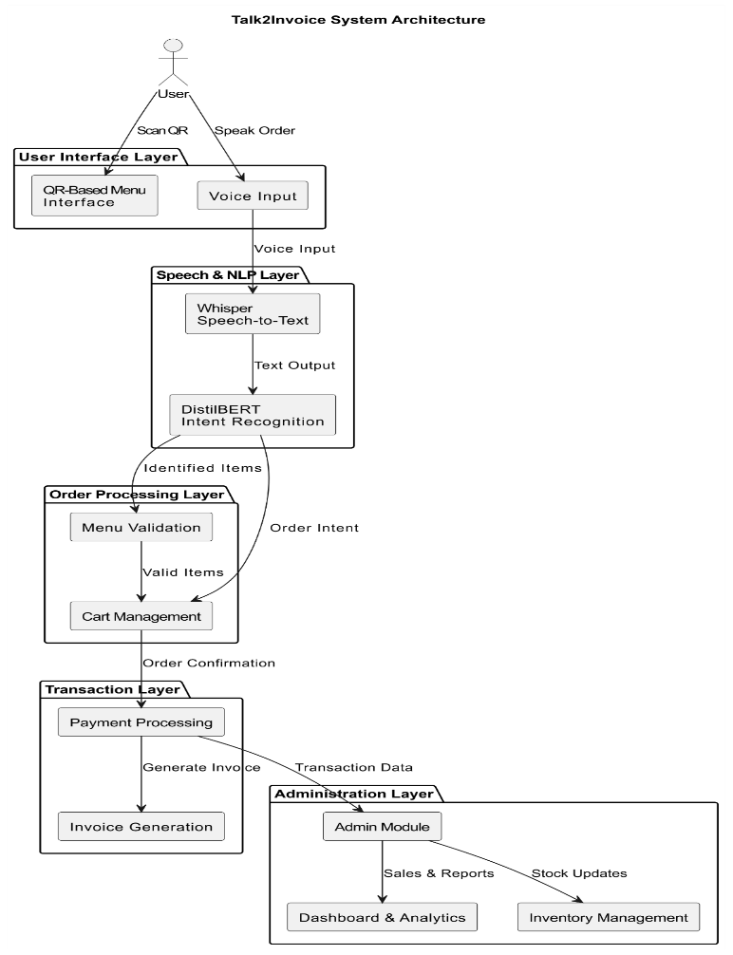Fig-2: Methodology flow chart
3.1 voice interaction and intent processing process.
This begins with a customer scanning a QR code in the restaurant which directs to a digital menu interface. The interface is browser-based and is easy and it allows the customers to use the system without the need to install an app. There is also an interactive element of voice in the menu.
The customer orders a product after talking to a device that has a microphone. Background noise or other speech patterns may be picked up by the recorded voice which is common in restaurants. This sound is sent to a Speech-to-Text (STT) engine which translates the request to text using the Whisper or Faster-Whisper engine.
Through the Intent Recognition module, the text is then run through a fine-tuned DistilBERT model. This model examines the context in order to determine what the user wants and extract appropriate information such as the name and quantities of menu items. The information that was interpreted is added to the cart temporarily and a voice confirmation message is issued by the system to enable the customer check the detected order before proceeding.
3.2 Processing and validation of orders.
Once the user affirms with the order observed, the system initiates the order processing stage. The backend performs feasibility checks prior to the acceptance of the order to make sure that nothing will go wrong.
The system determines the inventory first to identify whether the required items in stock. Meanwhile, it evaluates the workload of the kitchen so that the delays are not long, in particular, in peak times. Only the orders which comply with both the inventory and kitchen workload requirements are further processed. After the validation, the order is completed and assigned with a unique identifier, which aids in the tracking and reference during the life of the order.
3.3 Administrative and Backend Management.
Once the order is confirmed, the backend system safely stores the details of the order in database to track and keep the records of the order. Also, order and transaction metadata are stored in a blockchain-based ledger which ensures secure storage, immutability and transparency of records. This configuration facilitates in auditing, traceability and dependable recording of transactions.Once the order has been processed, a digital invoice is generated, which contains the details of the items and their quantities and prices and references of transactions. This is e-mailed to the customer.
There is an administrative monitoring interface where the restaurant personnel can monitor the manner in which the systems operate. With this interface, administrators are able to monitor the orders placed and orders fulfilled, control stored inventory, monitor kitchen workload and finally check on the transaction record. This centralized management facilitates proper control and proper management of the restaurant.
3.4 Model Training and Evaluation.
Talk2Invoice system has been trained and tested through a comprehensive method to make sure that the intent recognition is correct and the performance is reliable in real-time.
Model Training
The intent recognition component was realized with the help of a fine-tuned DistilBERT model that was trained on a selection of food item descriptions and utterances related to orders. The DistilBERT tokenizer was used to tokenize the text and AdamW was used to train with a batch size of 32 and a range of learning rates between $2×{10}^{-5}$to $5×{10}^{-5}$. Monitoring validation accuracy and loss during training was done and to prevent overfitting early stopping was used.

Inference and Post Processing
In inference the Whisper speech recognition model was used to first translate spoken user input into text. The output of that transcription was fed into the trained DistilBERT classifier to determine the intent of the user and the types of foods they wanted, which were converted to backend operations (order verification and invoice creation).
Model Evaluation
Accuracy and Macro-averaged F1-Score were used in evaluating model performance over a held-out test set. The intent recognition module had a maximum accuracy of 96.30%.
4. Experimental Results and Analysis
This part includes the discussion and analysis of the Talk2Invoice system experimentally. The analysis is based on the overall process of operation with emphasis to voice-based order placement, accuracy in intent recognition, backend validation, transaction processing, and administrative transparency. The findings indicate that the system is efficient in food ordering and invoicing in restaurants in real time.
4.1 System Workflow and Functional Results
The Talk2Invoice system has a definite workflow of user interaction to the invoice generation. To test the accuracy and reliability of the system, several order scenarios were used to test the system. Customers use a QR code to access the platform and see the menu in its digital format and make orders via natural spoken language. The voice input is transcribed into text through the Whisper-based Speech-to-Text engine which works effectively in a restaurant setting with moderate background noises.
The transcribed text is passed through a model that is based on DistilBERT to give a final prediction where the menu items and quantities are identified. The identified order is provisionally put in the cart and verified through the voice reply. Then, inventory availability and load in the kitchen are verified by backend services. Passing orders are finalized, assigned a unique order identifier and then digital invoices are generated.
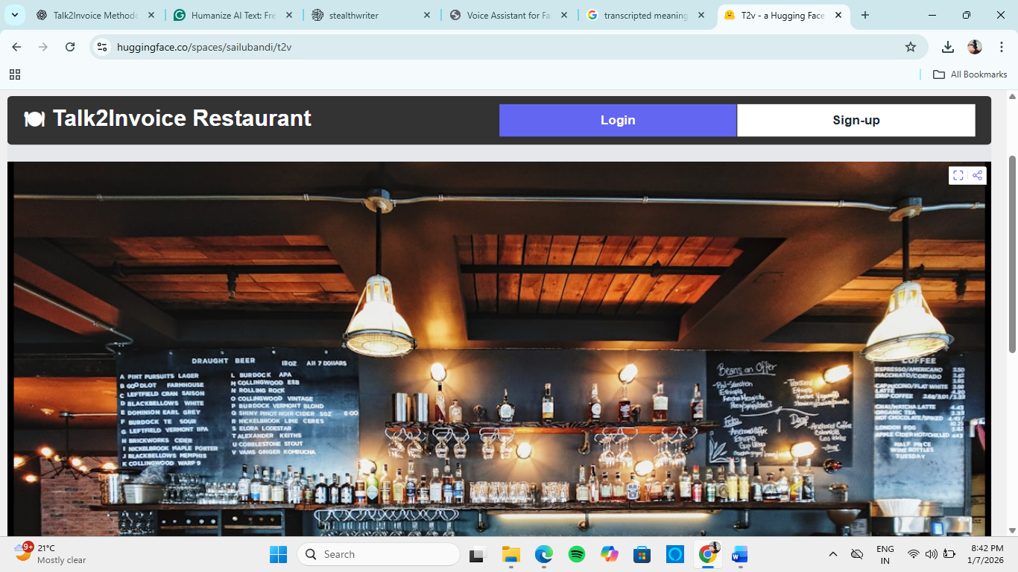
Fig-3: The Talk2Invoice Interface

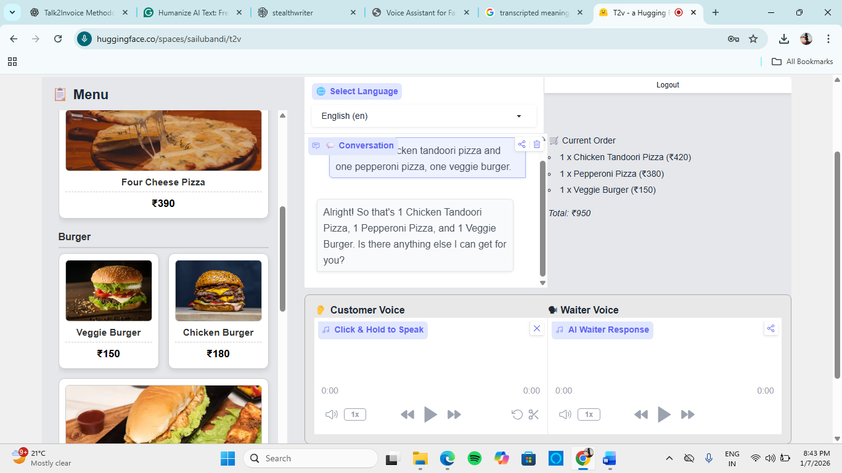
Fig-4: The Talk2Invoice Ordering Page
4.2 Model Accuracy of the Intent Recognition Model
We tested intent recognition model in terms of its capacity to find the correct interpretation of spoken food orders. Each input produces a single prediction of the model. The validation data were used to determine the accuracy and compare the predicted outputs against the true labels.
Throughout the training, the DistilBERT based classifier displayed consistent improvement and an accuracy of approximately 96% on the validation set. The trend of accuracy during training is that there is steady improvement with slight fluctuation in the final stages of training as a pointer of good learning and good generalization. This step of user confirmation will also contribute to the increased system reliability by making sure that no wrong orders can be confirmed.
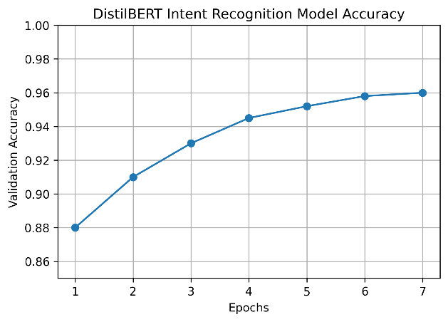
Fig-5: The validation accuracy of the DistilBERT intent order recognition model vs. training epoch.
4.3 Practical order Scenario validation
We evaluated the practical applicability of the system by testing the real-life application of the system to real restaurant order cases involving single-item and multi-item order requests.

Table 1: Order validation

Order ID | Verbal Request | System Interpretation | Status of the order
O01 | One Pizza and two cold drinks | Pizza ×1, Cold Drink ×2 | Successful
O02 | Two fries and a coke | Fries x2, Coke x1 | Successful
O03 | Chicken 3 burgers | Burger x3 | Successful

The backend validation modules were successful in disallowing unavailable items to be processed and designed a workable kitchen workload. Such findings affirm the validity and accuracy of the order processing system in the real situation.
4.4 Administrative Visibility and Transaction logging.
Once an order is confirmed all the details of order and transactions are stored in the backend database which is secured. Also, transaction information is stored in a blockchain-based registry, which is secure, traceable, and transparent.
A dashboard in the administration provides real-time access to orders being worked on and orders completed, inventory levels, kitchen workload, and transactions. This centralized monitoring facility aids in good supervision, auditing and operational control both in normal and peak business hours.
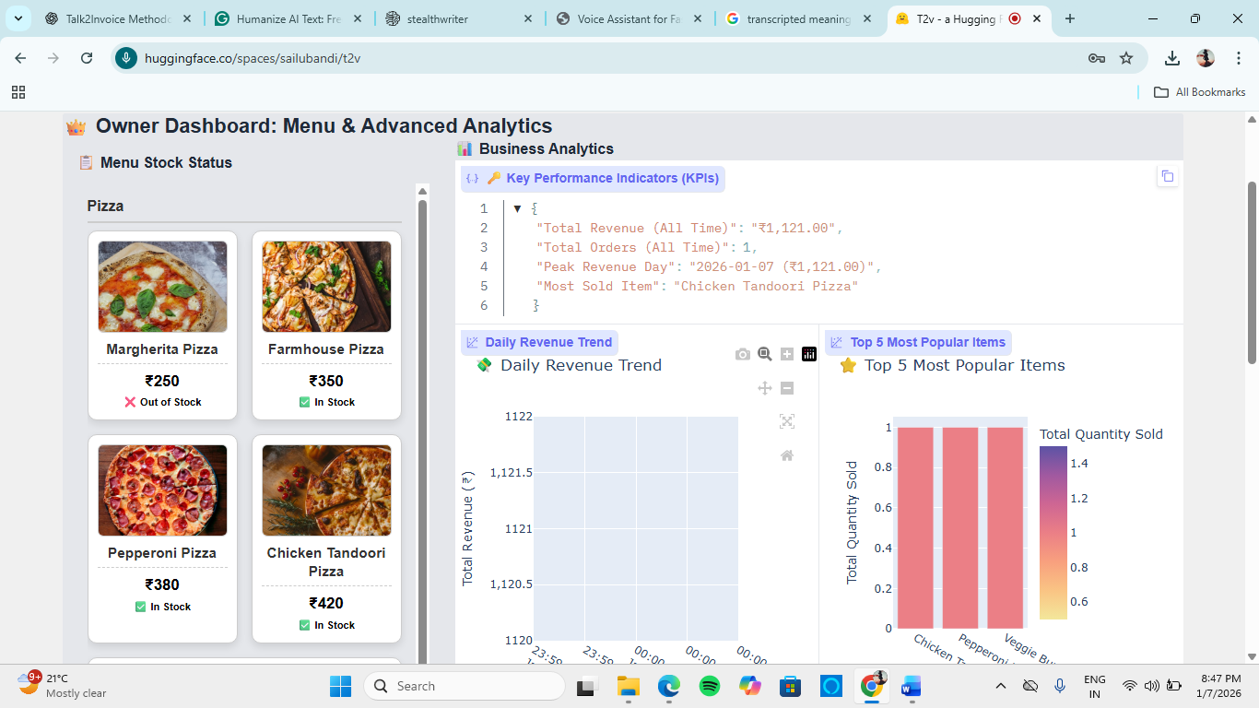
Fig-6: The Talk2Invoice Owner Dashboard
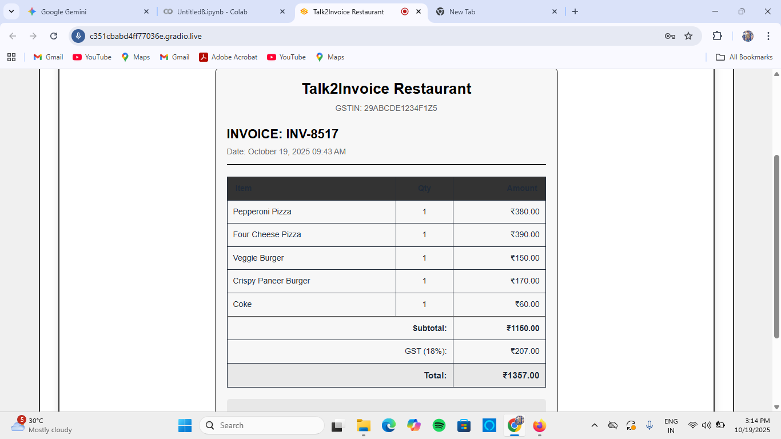
Fig-7 The Talk2Invoice Generated Invoice
5. Discussion
This part will include the findings of the Talk2Invoice system and the success of the system in the actual restaurant environments. It presents some key findings, advantages of the voice approach. The findings indicate that Talk2Invoice is a stable, effective, and convenient system to use in automated food ordering and invoicing.
5.1 Major Findings and Implications.
The findings suggest that Talk2Invoice manages to automate the whole process of restaurant ordering by means of voice interaction. This system is a combination of speech-to-text conversion, intent recognition, backend validation, and invoice generation. The intent recognition model implemented using the DistilBERT model has a validation accuracy of approximately 95 to 96, which can be interpreted as high capability in comprehending the intent of the users correctly and recognize sequential items and quantities in natural language. The good generalization with the various ordering patterns and the smooth training process indicates stable learning.
Operationally, combining inventory verifications and kitchen load authentication are a huge reduction in the number of order rejection and preparation delays. These results suggest that voice ordering system using AI has the potential to increase the service quality and reduce the need to enter orders manually, particularly during the peak time in restaurants.
5.2 Benefits of the Proposed System.
Talk2Invoice system has a number of advantages compared to the traditional menu-based or manual ordering systems. It lowers significantly the time and effort required by customers to make orders since they can do it through their voice. This is an intuitive type of communication that is not complicated even by users with different backgrounds and technology. The intent recognition is based on AI and guarantees a high level of accuracy, mitigating such frequent errors as the wrong choice of item or a wrong amount of items.
Also, real-time backend verification improves the efficiency of operations since the lack of a certain product in the menu does not lead to the order, and the workload of the kitchen is not increased in advance. Additional usability is also facilitated by the administrative dashboard which gives continuous access to orders, inventory, and records of transactions. Preservation of secure transaction logging ensures that audits and performance reviews are possible due to the transparency and traceability. In general, the design of the system is modular and scalable, which allows it to be used in both small restaurants and large food service chains.
6. Future Directions
The system analysis and the experimental evaluation demonstrate that the Talk2Invoice may be used as a voice-based service to order food. It is an integrated Whisper speech recognition, DistilBERT intent comprehension, and automated backend processing. Although our current prototype is good in a controlled environment, we still require upgrade on scaling, reliability and preparedness in application in the real world. The scope of future research will be to increase the size of training data, to streamline the efficiency of models and to come up with lightweight deployment strategies in large-scale food service settings.
6.1 You-Smart Personalization and Recommendation Engine.
The next generation of Talk2Invoice can be developed with intelligent personalization and recommendation as the new features to enhance customer interest and performance. The system will be able to offer customized meals, combo deals, and more specific suggestions based on historical order information, time trends, and trendy menu items. Such features may result in customer satisfaction, repeat use, and assist restaurant operators in demand forecasting, menu enhancement, and promotion.
6.2 Improving Conversation Intelligence and Personalization.
Subsequent versions of Talk2Invoice can go beyond the simple commands to more intelligent conversational intelligence. We will be able to implement context aware dialogue management to facilitate the use of multi-step and conversational ordering tasks. The system should be able to adapt to the user, which is possible by including sentiment and emotion analysis based on the vocal cues. Individual based recommendation engines with user preferences and eating patterns can even enhance system intelligence and involvement.
6.3 Security, Privacy and Ethical Implementation.
As the Talk2Invoice deals with sensitive user data, such as voice records and transaction records, the future work should be on data security, the protection of privacy, and the ethical utilization of AI. This entails the use of secure data encryption, access controls, and adherence to the laws of data protection. Such aspects of ethics as transparency of AI-related decisions, informed user consent, and minimization of bias across languages and accents will play a critical role in the implementation of the system responsibly and reliably.
7. Conclusion
This paper discussed the use of artificial intelligence in automated voice-based food ordering, and showed how AI systems can be used to improve the accuracy, efficiency and scalability of restaurant operations. The proposed Talk2Invoice system is a combination of the Whisper and Fast Whisper models of multilingual and noise-resistant speech recognition and a fine-tuned DistilBERT model of intent recognition. On experimental implementation, it is found that the architecture can be used to support real time, hands free interaction that is suitable in high traffic food service settings.
One of the main contributions made by this work is that it resulted in the creation of end-to-end intelligent driver-involving a voice input and backend automation, involving inventory validation, order management, and automatic invoice creation. The blockchain-based backend is used to guarantee safe, transparent, and immutable records of transactions, whereas analytics dashboards allow continuously monitoring and making decisions based on data.
The applications are not limited to basic ordering, which can be used to contribute to smart food service infrastructures. The system will help lower manual workload, shorter service delivery times, and customer confidence due to frequent order processing and effective e-invoicing.However, despite the promise of this, more research is needed. Future research will also be on multilingual dataset growth, lightweight deploying of edge, adaptive and privacy conscious intelligence and mechanisms. The research forms a good basis in the development of the next generation AI-based restaurant automation.
8. REFERENCES
[1] Srinivasan, S., Raghavan, A., & Balaji, V. (2024). Voice assistant for fast food restaurants using DistilBERT. International Journal of Advanced Computer Science and Applications, 15(2), 412–419.
[2] Kim, J., Park, S., & Lee, H. (2020). System and method for providing voice assistance service. IEEE Access, 8, 145321–145330.
[3] Zhang, Y., Liu, H., & Chen, X. (2020). Research and application of intelligent voice food ordering system. Journal of Intelligent Systems, 29(1), 1123–1134.
[4] Shirode, A., Rathod, T., Wanjari, P., & Halbe, A. (2020). Speech oriented virtual restaurant clerk using web speech API and natural language processing. In Proceedings of the International Conference on Computing, Communication and Automation (pp. 1–6). IEEE.
[5] Kumar, A., Verma, S., & Singh, R. (2022). A review on voice assistants in our daily life. International Journal of Computer Applications, 174(12), 1–7.
[6] Ashfaq, M., Yun, J., Yu, S., & Loureiro, S. M. C. (2021). “It’s on its way”: Chatbots applied for online food delivery services—social or task-oriented interaction style? Journal of Retailing and Consumer Services, 62, 102596.
[7] Patil, S., Kulkarni, A., Deshmukh, R., & Joshi, P. (2021). Vocalicious: Voice-assisted food ordering web application. In Proceedings of the International Conference on Smart Computing and Informatics (pp. 455–463). Springer.
[8] Rathod, T., Shirode, A., Wanjari, P., & Halbe, A. (2020). Speech oriented virtual restaurant clerk using web speech API and natural language processing. International Journal of Engineering and Advanced Technology, 9(5), 2871–2876.
[9] Huang, L., Zhao, Y., Wang, J., & Wu, Z. (2025). HYLR-FO: Hybrid approach using language models and rule-based systems for on-device food ordering. IEEE Transactions on Artificial Intelligence, 6(1), 98–110.
[10] Alharbi, A., Alotaibi, S., Alshammari, N., and Almutairi, S. (2022). Deep learning and Internet of Things based smart voice-based restaurant ordering system. IEEE Access, 10, 118245–118257.

